CURRICULUM VITAE

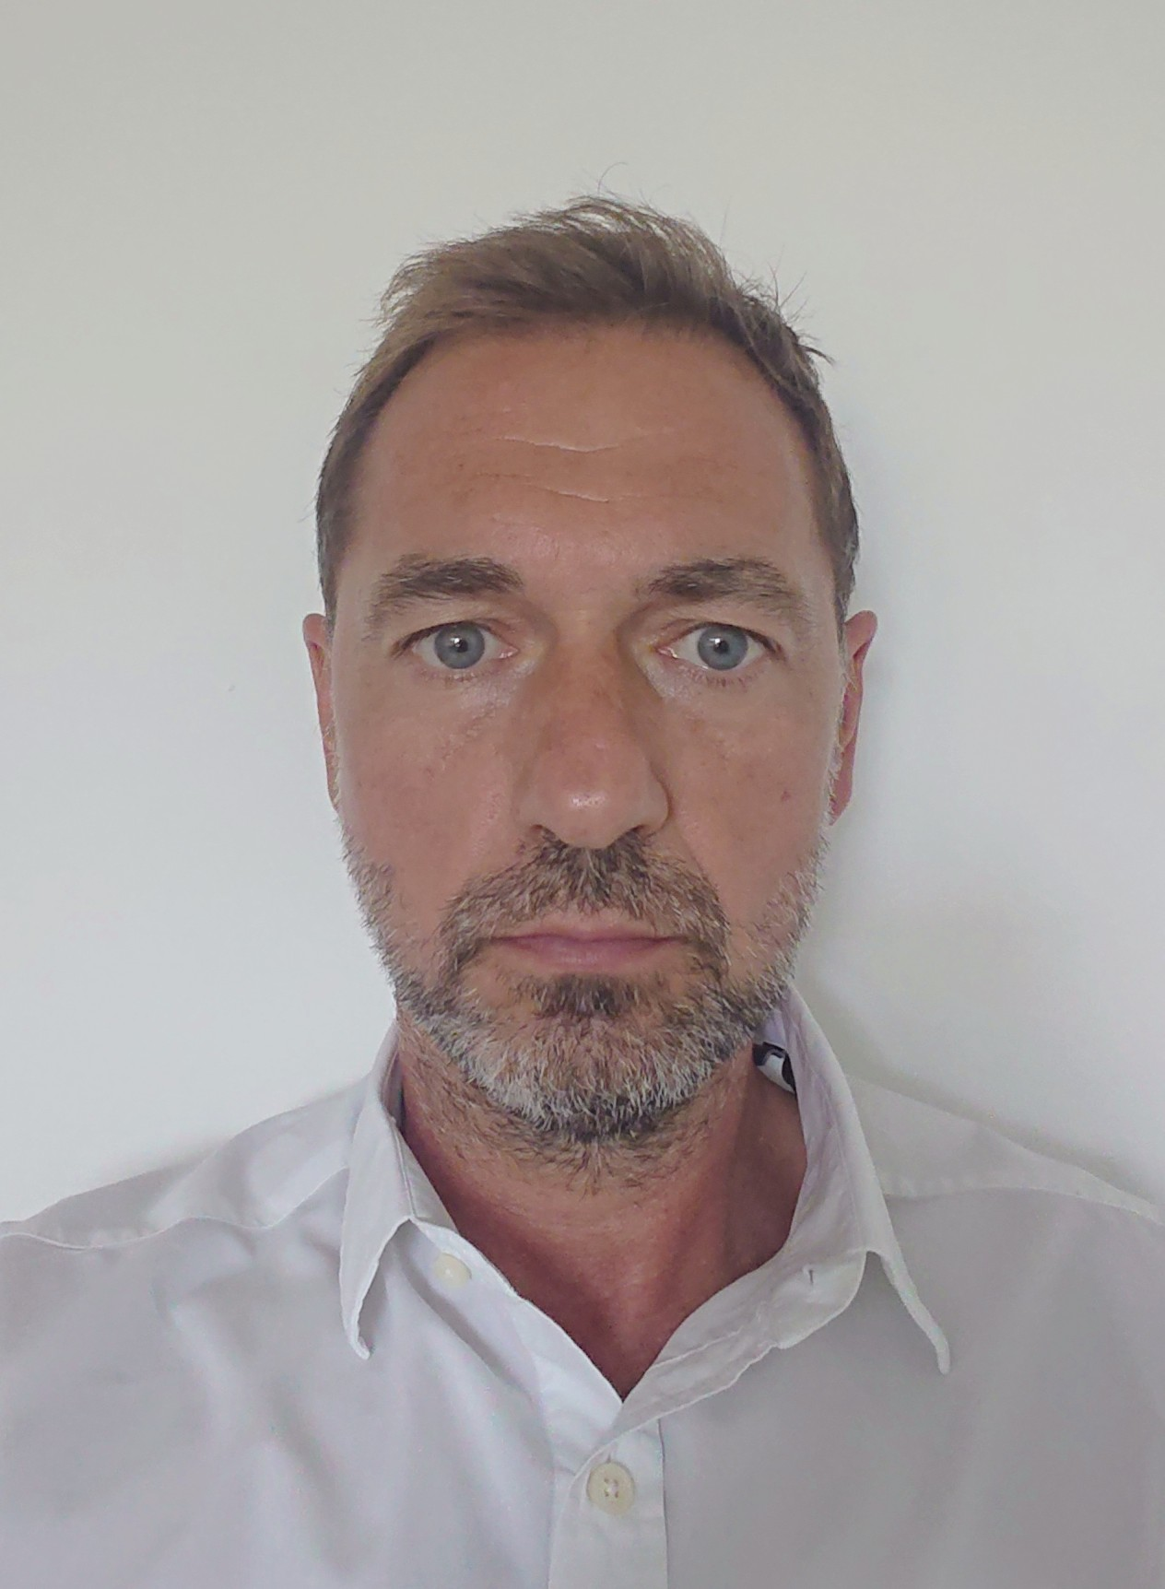

Personal
Name ZSOLT CSABA, NAGY
Address Lóránt út 22.
1125 Budapest, Hungary
E-mail zsnagy@vipmail.hu
Mobile +36-30-670-7670
DOB 2 November 1970
Marital status Single

Education
Winthrop University, South Carolina Jan. 1993 – Dec. 1996

Bachelor of Science – Major in Marketing (minor in Finance)
Achieved Dean’s Honor’s List
Móricz Zsigmond High School (Budapest, Hungary) 1985 – 1989

Employment history
Sport Management
- Representing and managing athletes
- Talmácsi Gábor – 2007 world champion motorcycle racer
  - Since 2012
  - Shell, Bridgestone, Vodafone, BMW, Lotus Cleaning, Alcoa
- Nagy László – handball player – Szeged, FC Barcelona, Telekom Veszprém
  - Since 2015
  - Bodrogi Bau, Total, Polifarba, Bomba

Nagoo Marketing Solutions Kft.
Managing Director/Owner March 2011 – Present
- Marketing strategy development
- Communication strategy develpment
- Product development
- Creative development – key visuals
- 360 degree marketing
- Film production
- Foto shooting
- Working for multinational companies: Zwack, Trigranit, Szentkirályi, Scitec Nutriton, Chio, Mikrocredit
- Working for privatly owened companis: Ford Petrány, Wolgupo, Ceralbin, Petrányi Pince, Lajver winery, Rackbon, Lotus Cleaning, Bodrogi Bau, Bátorfi Dental, Next Auto
- Sport managment
- Managing – Talmácsi Gabor – 125cc world champion, Nagy László – BL champion handball player (Barcelona, Telekom Veszprém), 199 hungarian nation team appearance

Hell Energy Drink Kft.
International Marketing Director April 2009 – June 2010
- Responsible for international activation
- Market development in UK and launch campain
- Responsible for revenue numbers.
- Development of Hell sport mangement strategy
- New product development
- Advertising strategy and creative developmen
- F1 – Williams contract

LG Electronics Magyar Kft.
Regional Sales Director June 2008 – March 2009
- Responsible for 7 countries – Hungary, Bulgaria, Serbia, Croatia, Bosnia, Macedonia, Albania
- Exploring business opportunities and developing new markets for the company
- Responsible for revenue numbers.
- Development of customer relationships and sales strategies
- Identifying new channel partners and market opportunities for the sales of products.
- Defining new partner policies, structures and processes for the Serbian market.
- Devised a new sales incentive scheme that was adopted
- Relationship management in major accouonts and responsible to build a team for the business operations.
- Managing 5,4 M Euro annulas sales budget
- Increased total sales revenue from 31,8 M Euro to 40,1 M Euro by 25,6%, majority of the growth came from Hungary (9,2 M Euro to 16 M Euro)
- Reporting to the Central and Eastern Region Managing Director
- Responsible for 18 people in 4 countires

Regional Marketing Director August 2006 – June 2008
- Responsible for 7 countries – Hungary, Bulgaria, Serbia, Croatia, Bosnia, Macedonia, Albania
- Establishing regional marketing department in Hungary with roles and responsibilities
- Efficient marketing spending (ROI) delivers significant brand impact (instore, online, ATL)
- Build PR network in the region with 4 PR agencies and engage in LG PR network
- Manages PR agencies pitches in 4 countries
- Manages regional creative material and media agencies
- Develop market research approach – consumer insight, go to market strategy
- Supports the countries in yearly media strategies and leads regional media briefings
- Strategic marketing planning on the ABP, 15 M USD budget responsibilities
- Representing LGEMK on top executive meetings
- Reporting to the Central and Eastern Region Managing Director
- Responsibel for 10 people in 4 countries
- Business results : GP -2006 32% (230 M USD), 2007 38% ( 309 M USD) growth
PR value– 2007 45% growth

PepsiAmericas Kft.
Regional Marketing Director - carbonated soft drinks April 2005 – June 2006
- Leading strategic planning process and develop total business strategy
- Define long term CEG business priorities and build strategies to address brand priorities
- Constantly seeks for category OI improvements and market share gains
- Manages regional creative and media agencies contract and cooperation
- Supports the countries in yearly media strategies and leads regional media briefings
- Guides and support divisions for executional excellence through AOP planning process
- Align countries on strategic plan, AOP and ensures Trimester programs consistency with AOP
- Act as a brand steward in overseeing local initiatives and executions
- Defines and owns regional production budget and supervises regional creative development budget
- Oversees and supervises new product development agenda with R&D, supply chain and Pepsi International
Red Bull Hungaria Kft.
Marketing Director May 2002 – Aug 2004
- Responsible for all aspects of marketing, including strategic and hands-on operational aspects; manages a budget of 5m USD
- Built up the marketing organization from two to 7 direct reports and 24 doted line reports; set-up job descriptions and goals, performance measures and compensation; developed a high performing team through coaching
- Increased sales by 26% in 2002 and 31% in 2003; making Red Bull the market leader in retail and impulse channels
- Won market share from major local competitor by the synergy of the adaptation of global corporate strategy and locally developed strategy
- Led the overall company strategic and annual planning process, as a GM since Jan. 2003
- Redefined the media strategy and subsequently ran a new tender for media agencies
- Global champion of a major new out-of-the-box marketing initiative (Air Race)
Unilever Hungary, Croatia and Slovenia 1997 - 2002
Product Group Manager May 2000 – May 2002
(Personal Wash)
- Was responsible for full P&L for the Personal Wash Category in Hungary, Croatia and Slovenia, with a turnover of 23 million Euro
- Was responsible for all marketing strategies and activities on six brands (Dove, Lifebuoy, Baba, Lux, Amo, Caomilla) in three countries
- Delivered an overall portfolio growth of 25% in Hungary over the annual target
- Re-launched Lifebuoy in Hungary with new formulation, design and advertising, leading to an additional 48% growth, becoming the no. 1 shower gel brand in Hungary—all in a matter of 8 months
- Increased brand profit on a key local brand (Baba) by 18% through package innovation, TVC and a new line extension
- Key responsibilities in three markets included media planning, budget planning, trade activities, ATL, BTL, development and delivery of the annual and 8Q plans
- Represented the CEE region on Lifebuoy at global Unilever forums

Brand Manager Sep 1998 – Apr 2000
(Deodorants, After Shave)
- Developed a new strategy for the deodorant business based on the global “focus” strategy
- Developed TVC for international brands for the first time in Hungary (Axe, Rexona), winning a communication award
- Created a new product extension for Denim that was subsequently adopted by a number of international markets
- Was first to introduce BTL campaigns as a key tool in the marketing mix
- Established the first internet site and e-business strategy in Hungary (Axe)
Unilever Hungary
Assistant Brand Manager Oct 1997 – Aug 1998
(Detergent, Soakers)
- Managed the launch of Floraszept Automata washing powder from the basic concept to launch, including market research, product and advertising development
- Created the detergent push plan for the year
Trainee Jan 1997 – Sep 1997
(Personal Wash)
- Planned annual promotional activity and the introduction of the highly successful 3+1 soap promotion
- Performed continuous market analysis
Coopers & Lybrand
Management Consultant Intern May 1996 – Aug 1996
- Developed the market entry strategy into Hungary for a UK based company
- Analysed competitors’ pricing strategy and marketing activities

Key capabilities
Innovation
Works in a very structured manner, but also has the capability to think out-of-the-box at all levels. A key driver behind the innovation agenda at Unilever in the CEE region. Always looks for possibilities to grow the business, appropriately, both through strategy and tactical implementations.
Drive
Has a passion for winning from 15 years of competitive tennis player background.
People development
Developed many direct reports into successful brand and trade marketing managers through coaching and training. Managed to gel a brand new team of thirty through team building activities, and by providing common goals and common values.
Languages
Native language – Hungarian, fluent English, basic German

